**ASSIGNMENT 4**

1. Create a stored procedure in the Northwind database that will calculate the average value of Freight for a specified customer.Then, a business rule will be added that will be triggered before every Update and Insert command in the Orders controller,and will use the stored procedure to verify that the Freight does not exceed the average freight. If it does, a message will be displayed and the command will be cancelled.

alter PROCEDURE spcustomers_AvgFreight

@customer_id varchar(10),

@avgFreight real output

AS

select @avgFreight = (select avg(o.freight) as Avg_Freight from customers c

inner join orders o

on o.customer_id = c.customer_id

where c.customer_id = @customer_id

group by c.contact_name)

return @avgFreight

GO

CREATE TRIGGER orders_Check_Freight

on dbo.orders

after INSERT, UPDATE

AS

BEGIN

declare @freight real, @avgFreight real, @cust_id varchar(10)

select @freight = freight, @cust_id = customer_id from inserted

exec spcustomers_AvgFreight @cust_id, @avgFreight output

if(@freight > @avgFreight)

begin

RAISERROR('Entered freight value is greater than average freight value', 16, 1)

rollback transaction

end

END

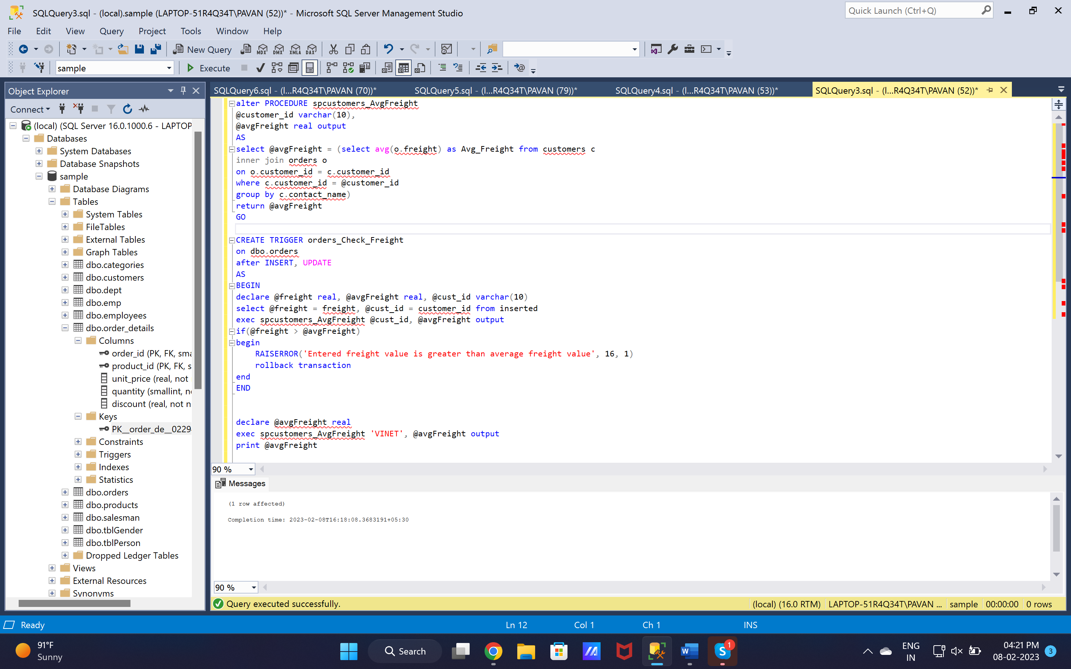

2. write a SQL query to Create Stored procedure in the Northwind database to retrieve Employee Sales by Country

create procedure spEmpSalesByCountry

@country varchar(15)

as

select e.first_name, e.last_name, count(o.customer_id) as total_sales, e.country from employees e

join orders o

on e.employee_id = o.employee_id

where e.country = @country

group by e.country, e.first_name, e.last_name

go

execute spEmpSalesByCountry 'USA'

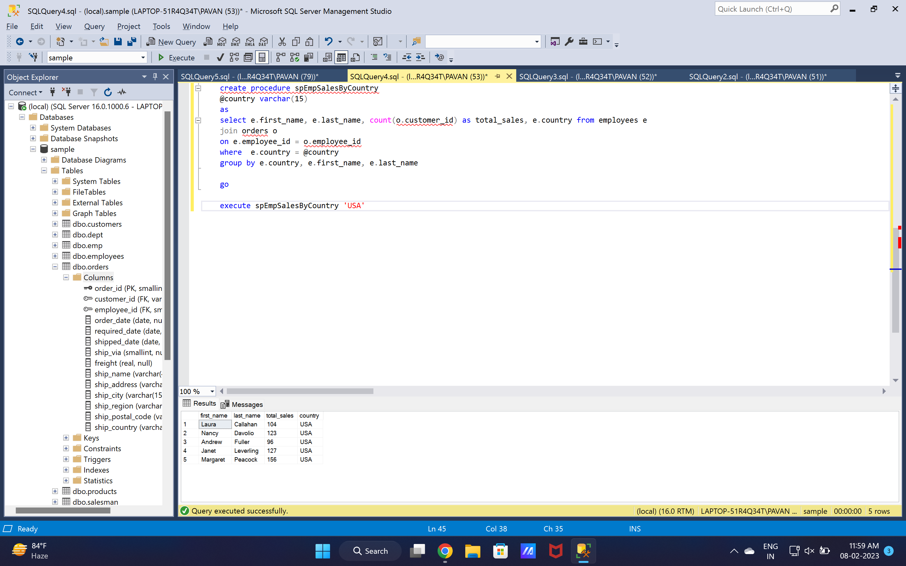

3. write a SQL query to Create Stored procedure in the Northwind database to retrieve Sales by Year

create procedure spSalesByYear

@year varchar(4)

as

select e.first_name, e.last_name, count(o.customer_id) as total_sales,

year(o.order_date) as sales_year from employees e

join orders o

on e.employee_id = o.employee_id

where year(o.order_date) = @year

group by year(o.order_date), e.first_name, e.last_name

go

execute spSalesByYear '1998'

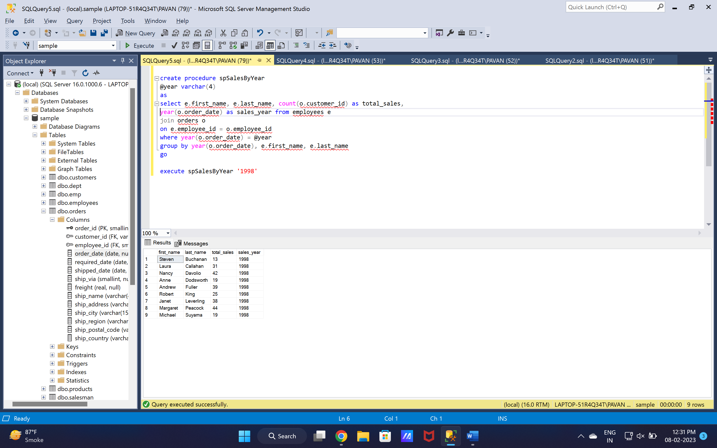

4. write a SQL query to Create Stored procedure in the Northwind database to retrieve Sales By Category

create procedure spSalesByCategory

@category varchar(20)

as

select count(o.order_id) as total_sales, c.category_name from orders o

join order_details od

on o.order_id = od.order_id

join products p

on od.product_id = p.product_id

join categories c

on p.category_id = c.category_id

where c.category_name = @category

group by c.category_name

go

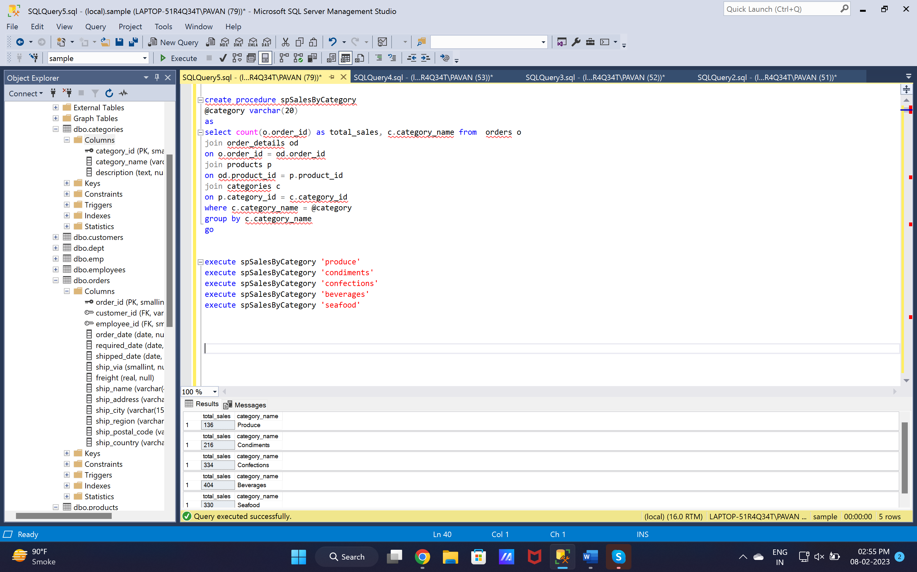

5. write a SQL query to Create Stored procedure in the Northwind database to retrieve Ten Most Expensive Products

alter procedure spMostExpensive

as

select top 10 od.unit_price as unitPrice, p.product_name from order_details od

join products p

on p.product_id = od.product_id

group by p.product_name,od.unit_price

order by od.unit_price desc

go

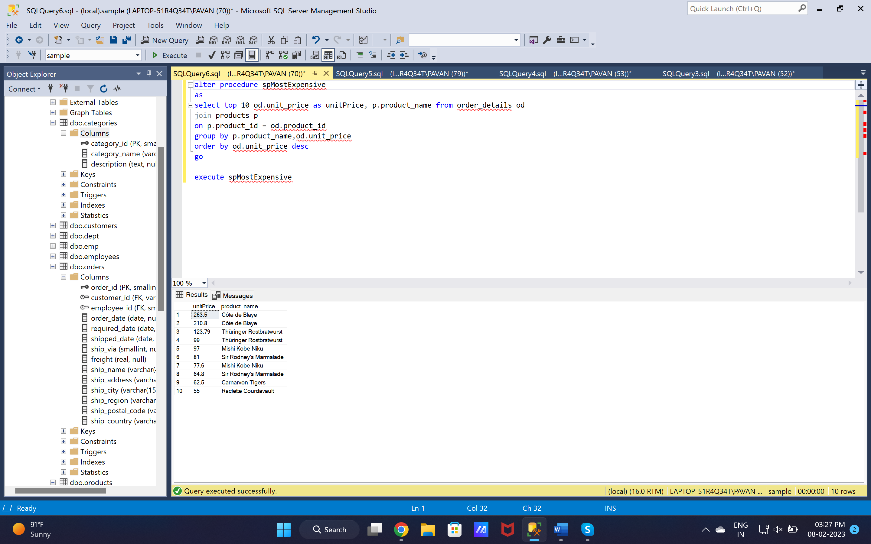

6. write a SQL query to Create Stored procedure in the Northwind database to insert Customer Order Details

alter procedure spInsertOrderDetails

@order_id smallint,

@product_id smallint,

@unit_price real,

@quantity smallint,

@discount real

as

begin

insert into order_details(

order_id,

product_id,

unit_price,

quantity,

discount

) values(

@order_id,

@product_id,

@unit_price,

@quantity,

@discount

)

end

go

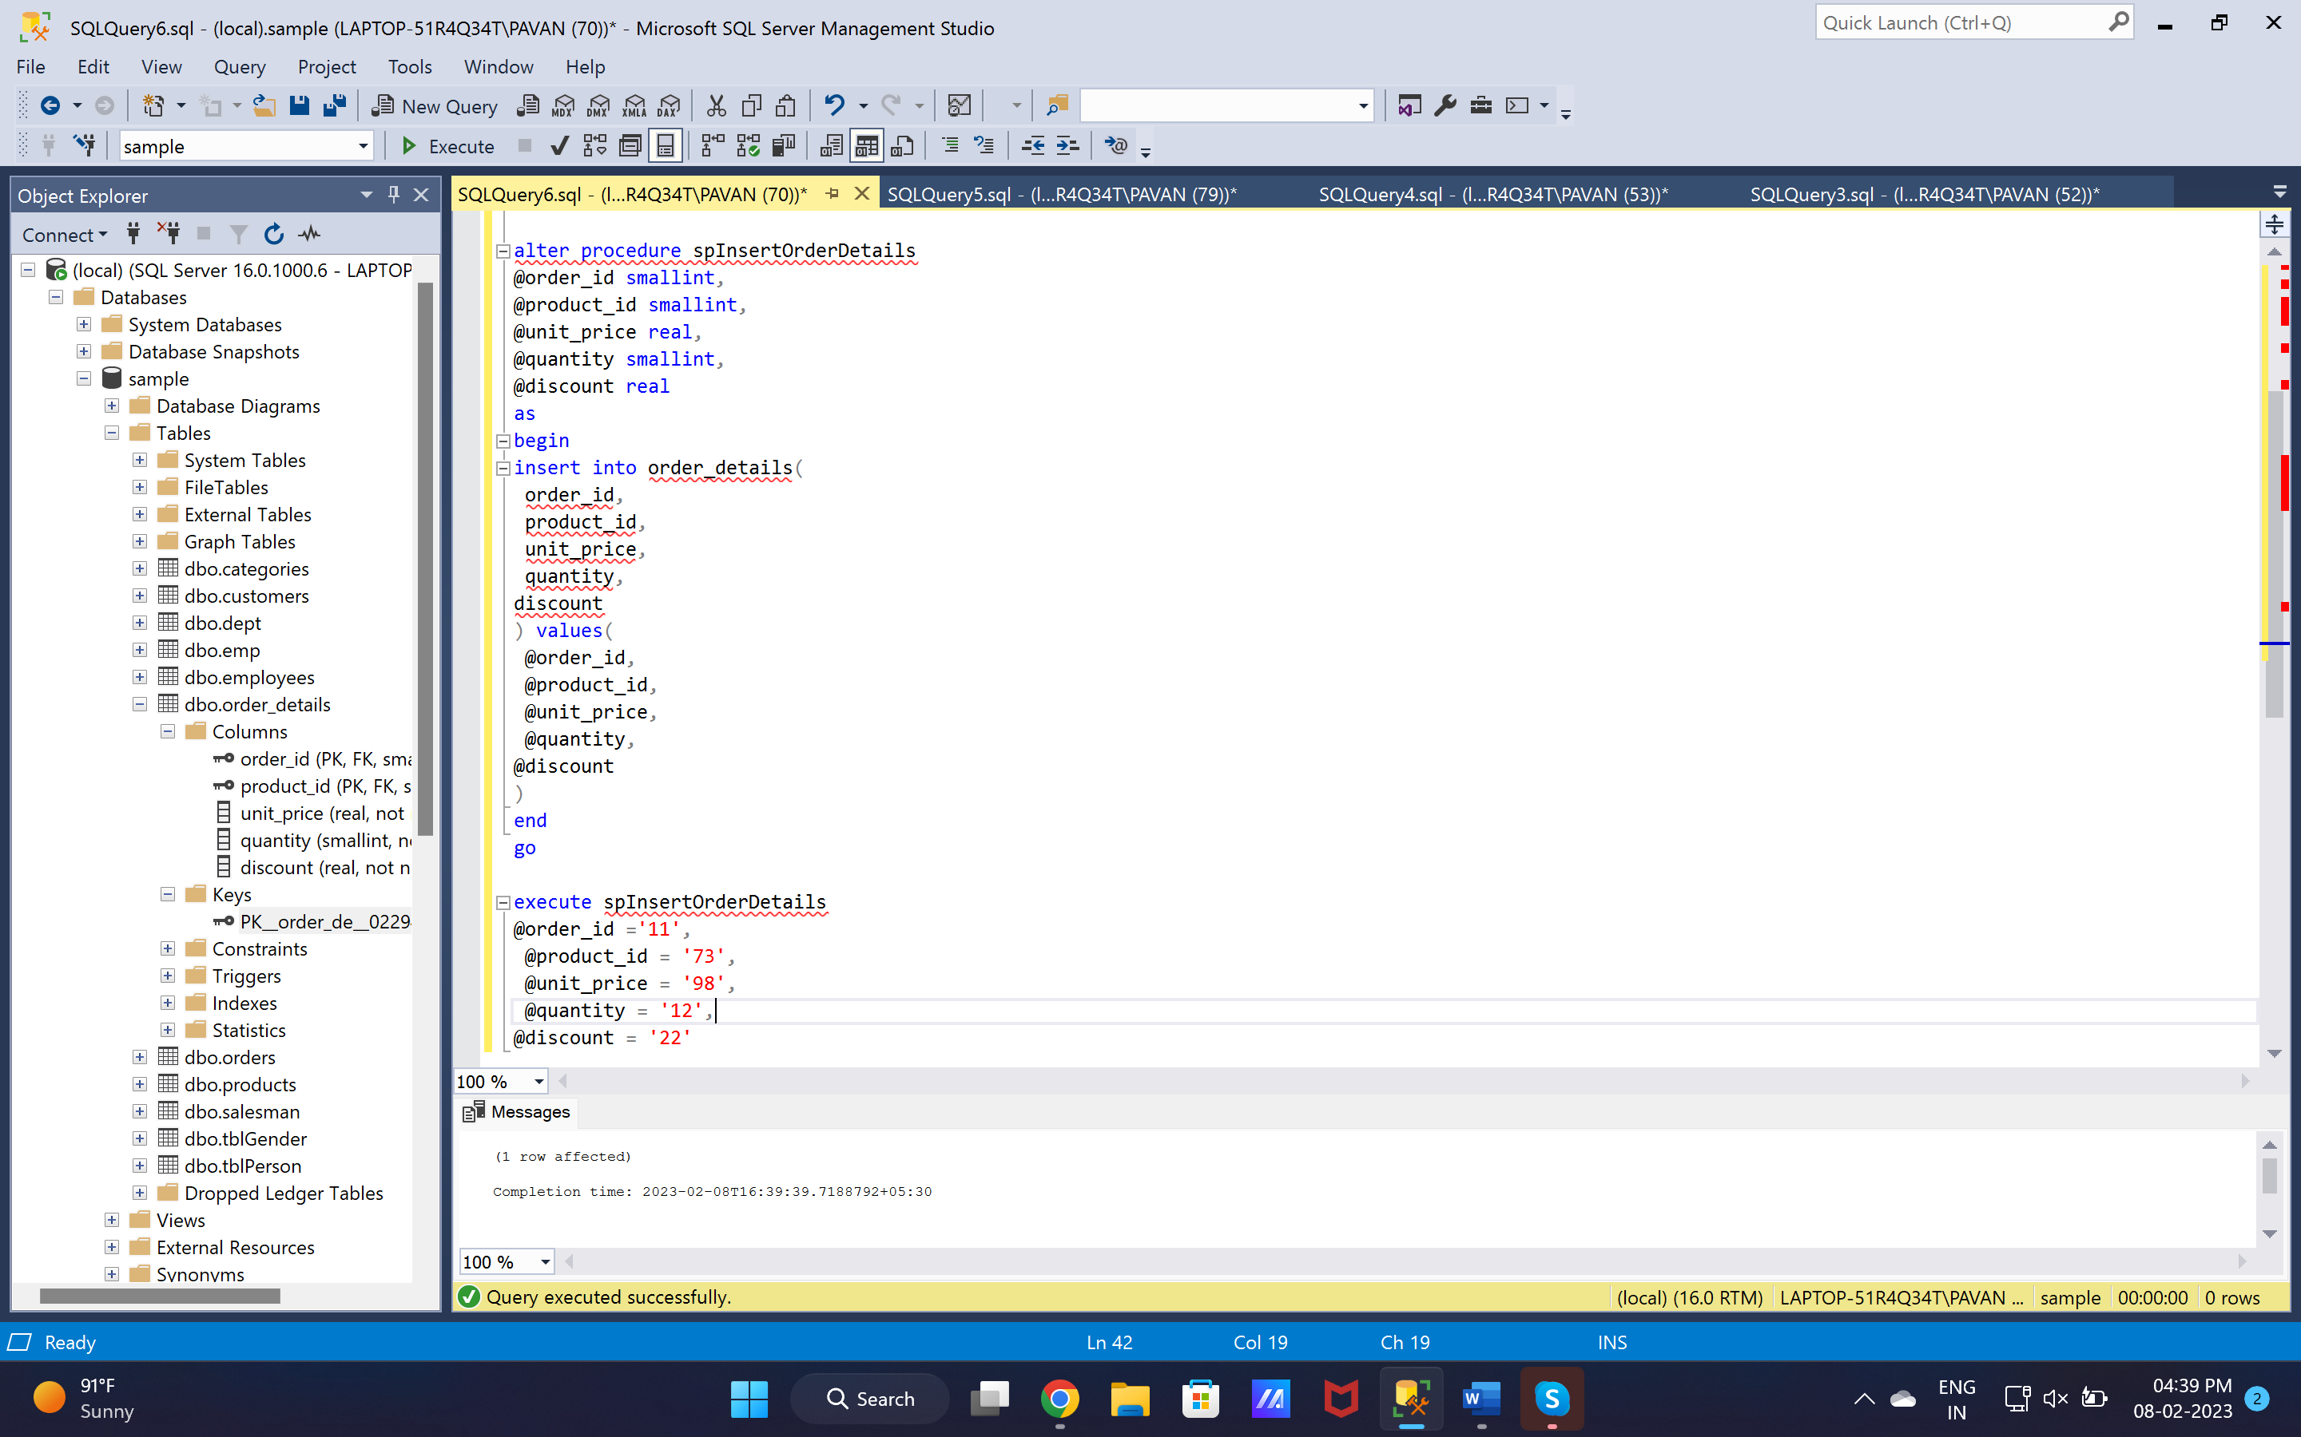

7. write a SQL query to Create Stored procedure in the Northwind database to update Customer Order Details

alter procedure spUpdateOrderDetails

@order_id smallint,

@product_id smallint,

@unit_price real,

@quantity smallint,

@discount real

as

begin

update order_details

set

unit_price = @unit_price,

quantity = @quantity,

discount =@discount

where order_id = @order_id AND product_id = @product_id

end

go

